CSIT314 Software Development Methodologies - Group Project

Sprint 4 - US27: Update past IDP
Interior Design Platform - Interior Designer
All diagrams were drawn in draw.io. Open "US27 Update past IDP.drawio" in this folder to edit them - each diagram is its own page in that file. The exported images are in the "diagrams" folder.

Assumptions
- The system is the Interior Design Platform from the project specification. Sprint 4 covers the Interior Designer's past IDP stories (add, view, update, delete and search, US25 - US29) and the Customer's save IDP, search saved list and view saved list stories (US33 - US35).
- We follow B-C-E: the actor only talks to the boundary (page), the boundary only talks to the controller, and the controller works with the entity classes. There is one controller per use case.
- The boundary checks all the input (required fields, lengths, formats, e.g. not suspending your own profile) and trims spaces, then passes an entity object on. The controller just calls the entity and returns the result. The entity checks for duplicates and the database state (e.g. name already used, only Active rows are changed), then saves. In US27 the page trims the input, builds an IDP object and checks every field rule itself; the controller just calls the entity; the entity only updates the owner's Active past IDP, and only into an Active category.
- An IDP is an interior design project. A current IDP is one the designer is still working on (US20 - US24); a past IDP is a completed one (US25 - US29). Both are rows in the idp table with projectType Current or Past.
- Logged in as an interior designer (UC13) is the precondition. designerLoginRequired in app.py only sends someone with no session to /designer/login; the use case doesn't check the designer again (no InteriorDesignerLoginController).
- "Update" on the past IDP's details (US26) loads the IDP with the controller's own loader getPastIDP(designerId, idpId). If it isn't the designer's Active past IDP, the system shows "Past IDP not found" (HTTP 404).
- The form has the same rules as US25: project title (required, 3-100 characters), IDP category (required, one of the Active ones), description (required, up to 2000) and location (optional, up to 200). No photos.
- The category drop-down only lists Active categories. Listing the categories is US45's job, so the page borrows SearchIDPCategoryController (empty keyword) and keeps the Active ones - the same way as US22 and US25.
- Only the title, category, description and location change. The owner (session userId), project type, status and created date never change.
- Saved: the details with "Past IDP updated successfully". Wrong input: "Please fill in all required fields" and the typed values stay. Not saved: the page asks getPastIDP() again - if the past IDP is gone (deleted meanwhile or not theirs) it shows "Past IDP not found" (HTTP 404), otherwise (e.g. the new category was suspended meanwhile) "Past IDP could not be updated. Please try again".

1. User story
Story ID | US27
User story | As an interior designer, I want to update a past IDP so that its details are correct.
Actor | Interior Designer
Priority | Medium
Story points (estimate) | 3
Acceptance criteria | 1. Given I am viewing my past IDP, when I click "Update", then the form opens filled in with its title, category, description and location.  2. Given I change the details correctly and click "Save changes", then only those four fields are saved and I see the past IDP's details with "Past IDP updated successfully".  3. Given a required field is empty, a field is too long or no Active category is chosen, then I see "Please fill in all required fields", what I typed stays and nothing is saved.  4. Given I click "Cancel", then I go back to the details and nothing is saved.  5. Given the IDP is missing, not mine, Current or deleted, then I see "Past IDP not found" (HTTP 404) and can't change it.  6. Given the save fails for another reason (e.g. the category was suspended between the check and the save), then I see "Past IDP could not be updated. Please try again" and what I typed stays.
Tasks | #189 Draw Use Case Diagram and Write Use Case Description  #197 Draw BCE and Sequence Class Diagram  #205 Implement editing and updating of existing Past IDP details in the database.  #249 Design Wireframe  #260 Write and Execute Test Cases

2. Use case diagram
The user story becomes one use case, UC27 Update past IDP. The Interior Designer is the only actor.
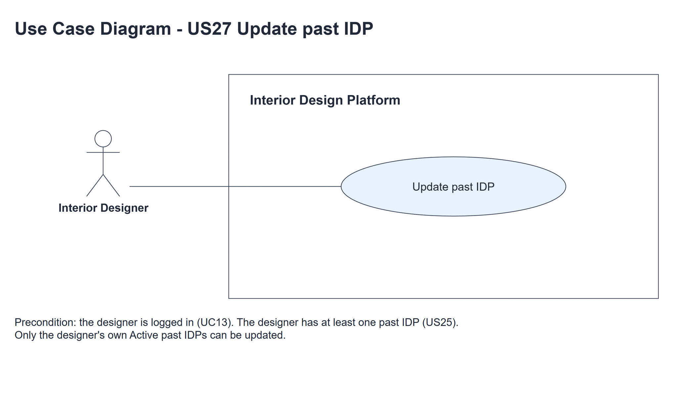
Figure 1: Use case diagram for US27 Update past IDP

3. Use case description
Use case | UC27 Update past IDP
Actor | Interior Designer
Brief description | The Interior Designer corrects the details of a completed project so customers see the right information.
User story | US27: As an interior designer, I want to update a past IDP so that its details are correct.
Preconditions | The Interior Designer is logged in (UC13). designerLoginRequired in app.py only sends someone with no session to /designer/login.  The IDP is the designer's own Active past IDP (UC25).
Trigger | The Interior Designer clicks "Update" on the past IDP's details (UC26).
Basic flow | 1. The Interior Designer clicks "Update".  2. The system loads the designer's Active past IDP.  3. The system shows the form filled in with the current details and the Active IDP categories.  4. The Interior Designer changes the details and clicks "Save changes".  5. The system trims the input and checks the fields (required fields, lengths and that the category is one of the Active ones).  6. The system saves the title, category, description and location if it is still the designer's Active past IDP and the new category is Active.  7. The system shows the past IDP's details with "Past IDP updated successfully".
Alternative flows | 2a. The IDP is missing, someone else's, Current or deleted: the system shows "Past IDP not found" (HTTP 404). The use case ends.  4a. The Interior Designer clicks "Cancel": the system goes back to the details and nothing is saved.  5a. A field is wrong: the system shows "Please fill in all required fields", highlights the wrong fields and keeps what was typed. Back to step 4.  6a. Nothing was saved and the system can no longer load the past IDP (it was deleted meanwhile or isn't the designer's): the system shows "Past IDP not found" (HTTP 404). The use case ends.  6b. Nothing was saved but the past IDP is still there (e.g. the new category was suspended between steps 5 and 6): the system shows "Past IDP could not be updated. Please try again" and keeps what was typed. Back to step 4.
Postconditions | The past IDP has the new title, category, description and location, and customers see them. The owner, project type, status and created date are unchanged.

4. Wireframes
The wireframes were drawn in draw.io. They are low-fidelity: they show the layout and the flow, not the final colours. The orange numbers match the notes under each screen.

4a - Update form
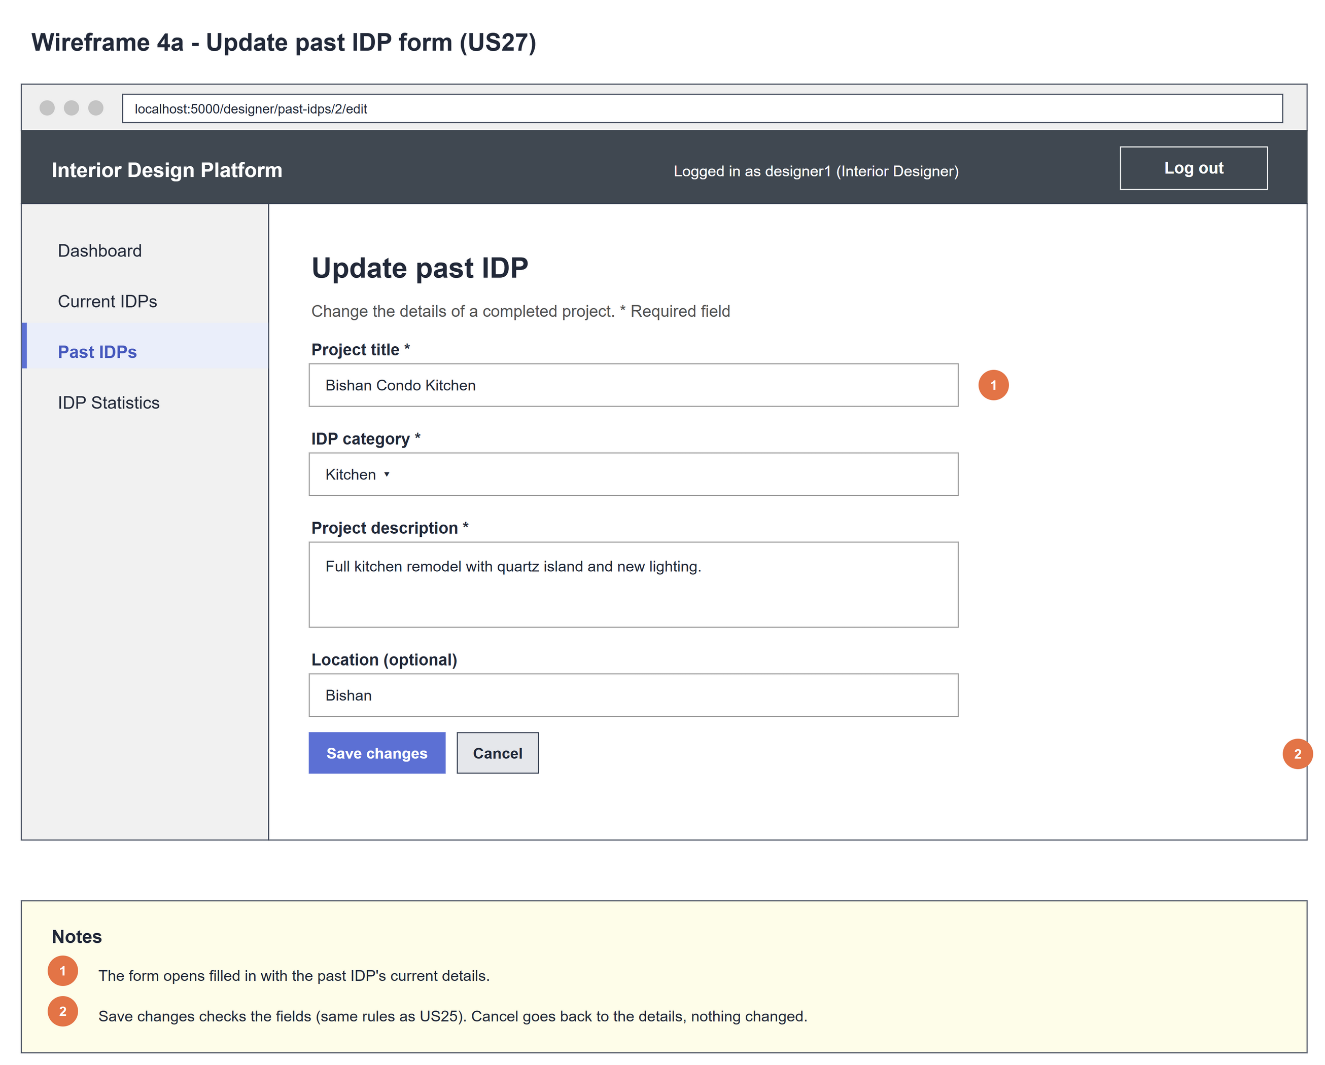
Figure 2: Wireframe 4a - Update form (US27)

4b - Update errors
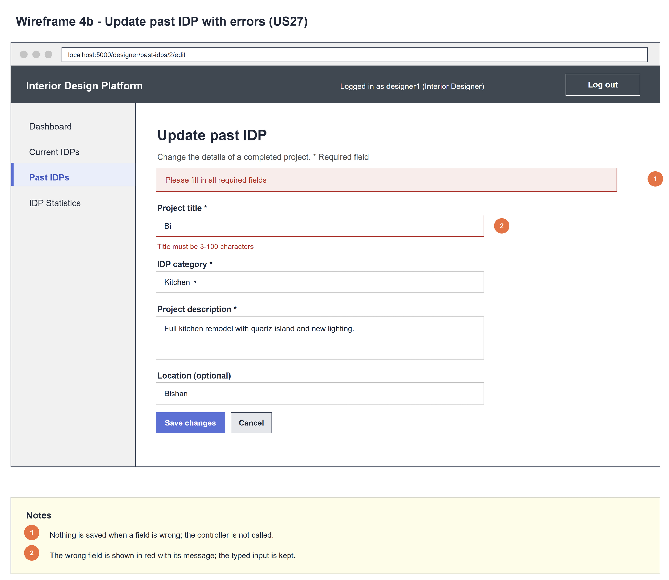
Figure 3: Wireframe 4b - Update errors (US27)

4c - Past IDP updated
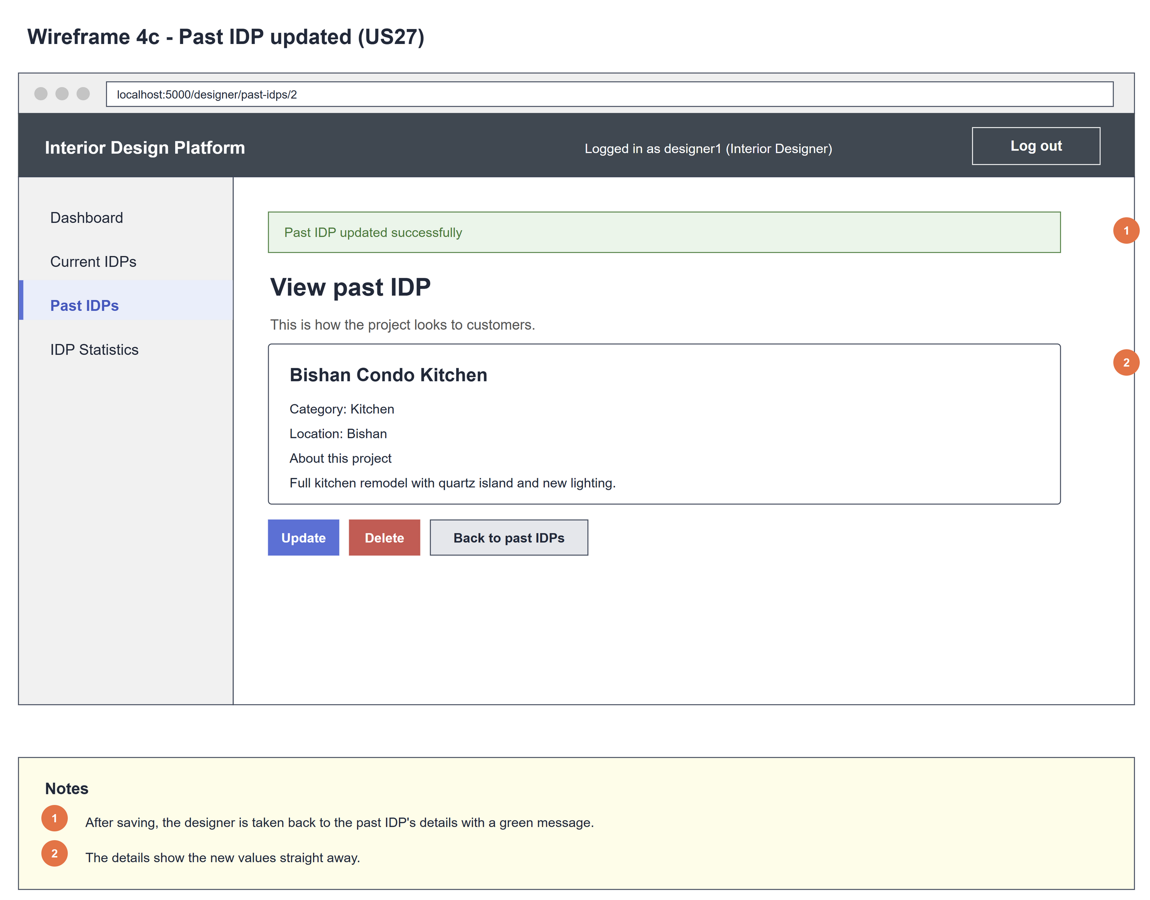
Figure 4: Wireframe 4c - Past IDP updated (US27)

4d - Past IDP not found
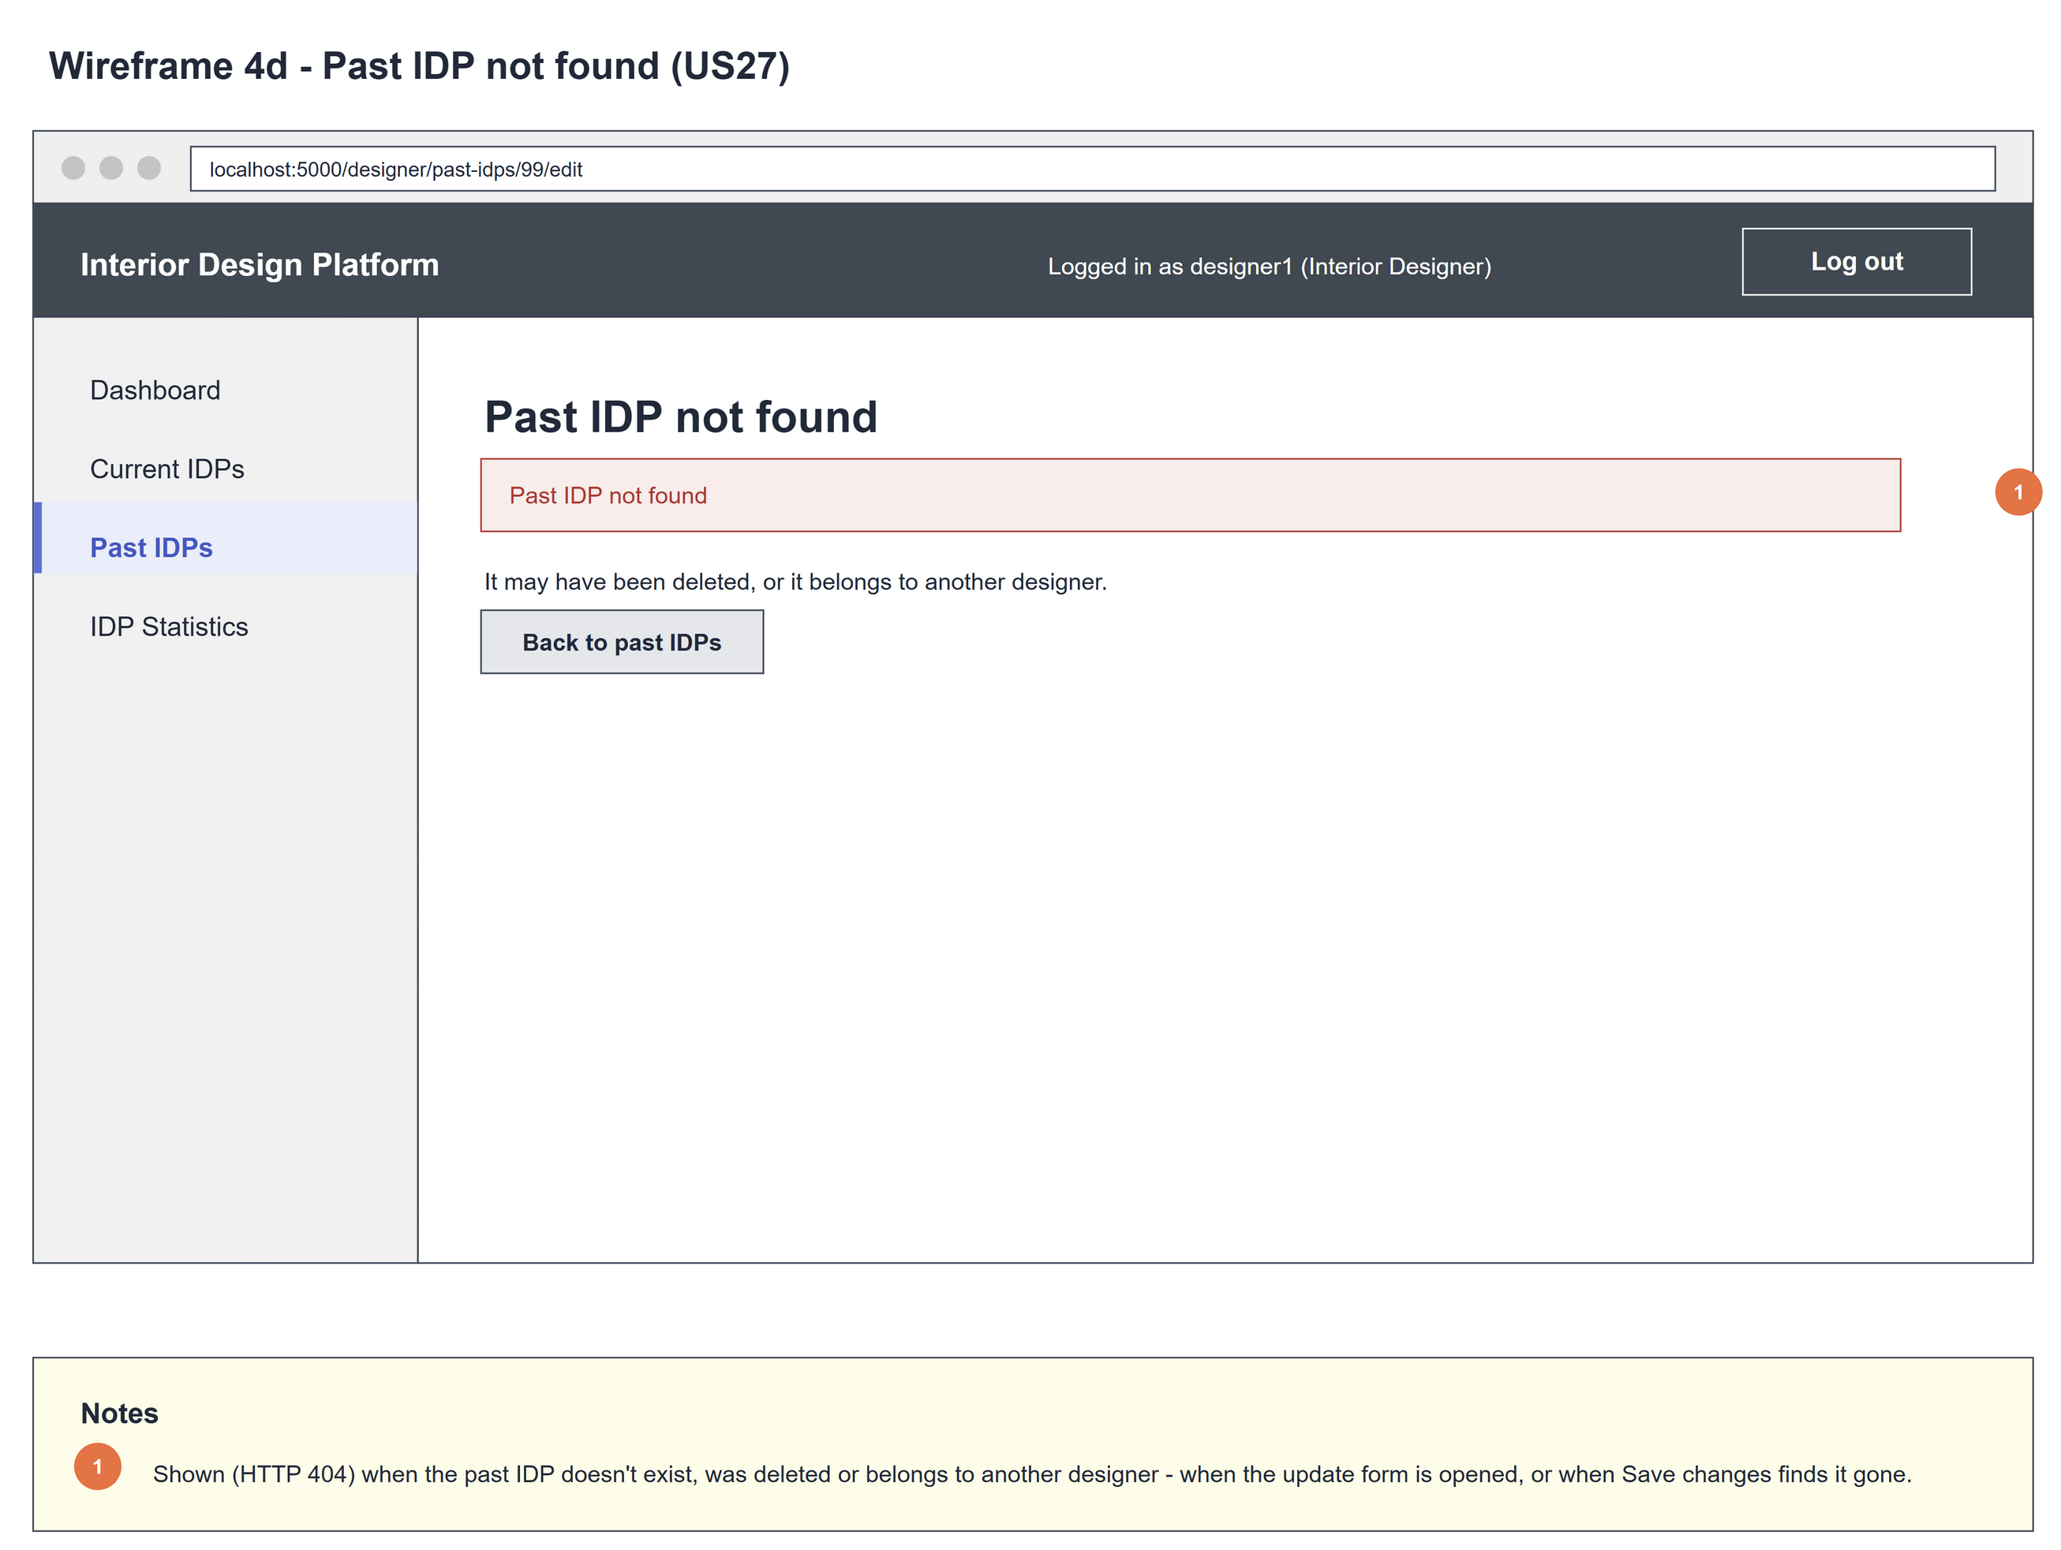
Figure 5: Wireframe 4d - Past IDP not found (US27)

5. B-C-E class diagram
The solid lines mean the boundary calls a controller: its own UpdatePastIDPController, and US45's SearchIDPCategoryController for the category drop-down. The dashed line means the controller uses the entity. Only the operations needed for this use case are shown.
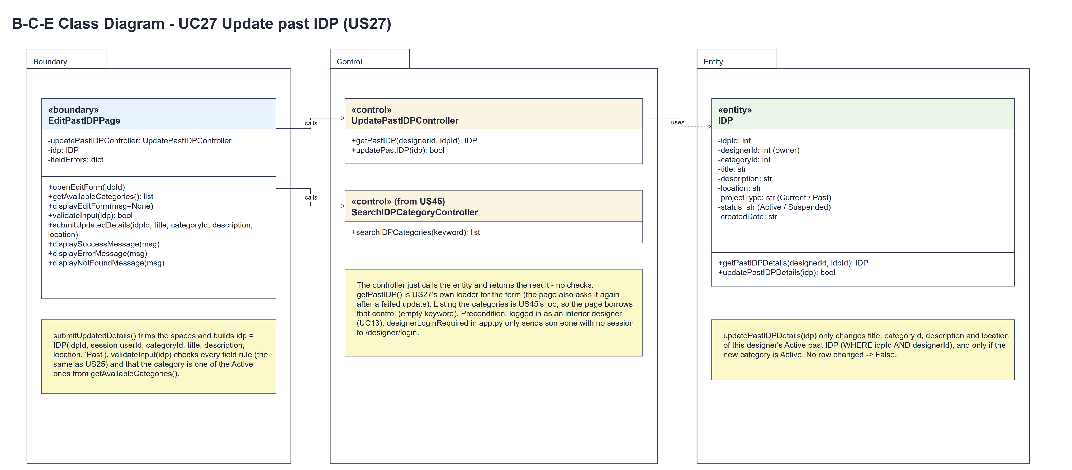
Figure 6: B-C-E class diagram for US27 Update past IDP
Layer | Class | What it does
Boundary | EditPastIDPPage | The update form. openEditForm(idpId) loads the IDP with getPastIDP() and shows displayEditForm() or displayNotFoundMessage(MSG_NOT_FOUND) (HTTP 404). getAvailableCategories() borrows US45's searchIDPCategories("") and keeps the Active ones. submitUpdatedDetails(idpId, title, categoryId, description, location) trims the input, builds idp = IDP(idpId, session userId, categoryId, title, description, location, 'Past'), checks it with validateInput(idp) (wrong -> displayErrorMessage(MSG_FIX_FIELDS)) and calls updatePastIDP(idp). Updated: displaySuccessMessage(MSG_UPDATED). Not updated: it asks getPastIDP() again and shows displayNotFoundMessage(MSG_NOT_FOUND) or displayErrorMessage(MSG_FAILED).
Control | UpdatePastIDPController | Controller for UC27. getPastIDP(designerId, idpId) is its own loader for the form and updatePastIDP(idp) just calls the entity and returns the result - no checks.
Control | SearchIDPCategoryController (from US45) | searchIDPCategories("") lists every category; the page keeps the Active ones for the drop-down and for checking the chosen category.
Entity | IDP | The only entity. getPastIDPDetails(designerId, idpId) returns the owner's Active past IDP, or None. updatePastIDPDetails(idp) changes title, categoryId, description and location only for that row and only if the new category is Active; no row changed -> False.

6. Sequence diagram
The sequence diagram follows UC27. Clicking "Update" calls the controller's own loader getPastIDP(designerId, idpId), which makes one call to IDP.getPastIDPDetails() (steps 1-2). The first alt shows the filled-in form with the categories the page borrows from US45 through getAvailableCategories() and searchIDPCategories("") (step 3), or the not-found page (2a). On "Save changes" the page trims the input, builds idp = IDP(...) and validates it, borrowing the categories again to check the chosen one (step 5). The outer alt saves when the input is valid: updatePastIDP(idp) makes one call to IDP.updatePastIDPDetails(idp) (step 6). The inner alt shows the details with "Past IDP updated successfully" (step 7); when nothing was updated the page calls getPastIDP() again and a nested alt shows the not-found page (6a) or the form with MSG_FAILED (6b). Invalid input shows the field errors (5a).
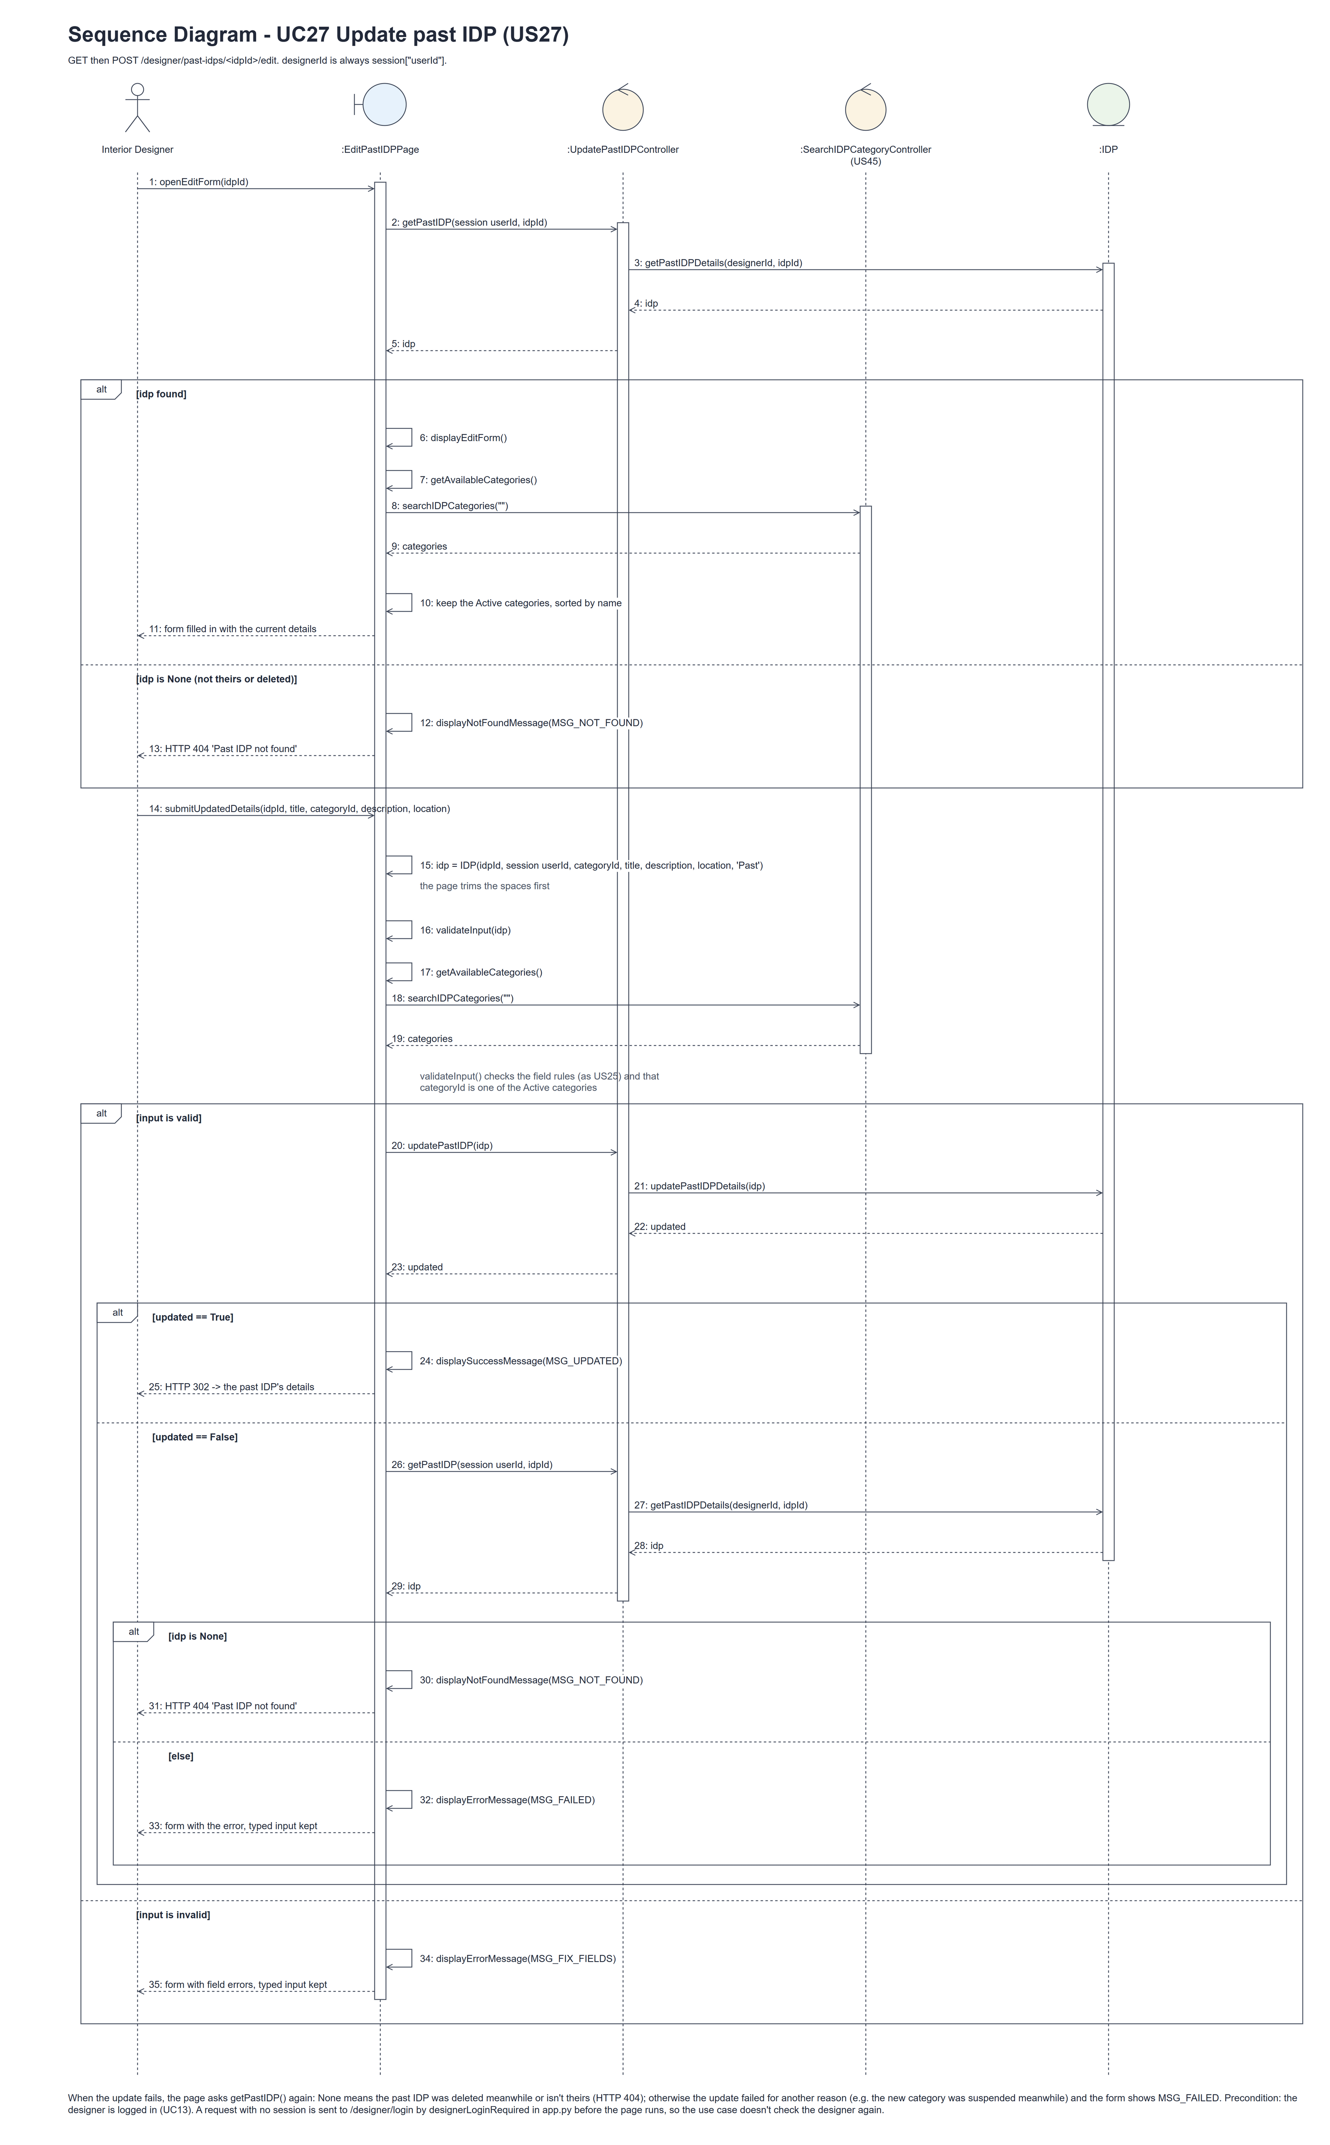
Figure 7: Sequence diagram for UC27 Update past IDP

7. Test cases
Test data used below (the same as tests/test_us27_updatePastIDP.py, which reuses the US25 helpers): designer accounts designer37 (A) and designer27b (B) / Design@123, made with UC8. IDP categories Kitchen and Bedroom (Active) and Old Style (Suspended). A owns the past IDP "Completed Kitchen" (Kitchen, "Test project"), a deleted past IDP and a current IDP; B owns a past IDP in Kitchen. New values (from the team's first Sprint 4 test): "Condominium 1-bedroom studio", Kitchen, "near mrt", Bugis.

7a. System test cases (black box)
Equivalence partitioning and boundary value analysis were used to pick the test data. Fill in "Actual result" and "Pass/Fail" after running each test.
Test ID | Scenario | Prerequisites | Test steps | Test data | Expected result | Actual result | Pass / Fail
TC27.1 | Filled-in form | Logged in as A. | 1. Open the past IDP's details / 2. Click "Update" | Completed Kitchen | The current values and the Active categories (Bedroom, Kitchen), not Old Style.
TC27.2 | Valid save | The form is open. | 1. Change the details / 2. Click "Save changes" | New values above | The details with "Past IDP updated successfully" and the new values.
TC27.3 | Title length (boundary) | The form is open. | 1. Enter each title / 2. Save | Empty; 2, 3, 100, 101 characters | 3-100 saved; empty: "This field is required"; 2: "Title must be 3-100 characters"; 101: "Maximum 100 characters". Nothing saved for those.
TC27.4 | Description and location (boundary) | The form is open. | 1. Enter each value / 2. Save | Description empty, 2000, 2001; location empty, 200, 201 | Empty description, 2001 and 201 characters are rejected; the others are saved.
TC27.5 | Wrong category | The form is open. | 1. Post a bad category / 2. Save | Missing or Old Style (Suspended) | "Choose an available category"; typed values kept; nothing saved.
TC27.6 | Cancel | The form is open. | 1. Change the title / 2. Click "Cancel" | Unsaved change | Back on the details; nothing changed.
TC27.7 | Spaces are trimmed | The form is open. | 1. Type the title with spaces around it / 2. Save | " Bishan Condo Kitchen " | Saved as "Bishan Condo Kitchen".
TC27.8 | IDP not available | Logged in as A. | 1. Open / post the update URL of each IDP | B's IDP, A's deleted and current IDPs, 999999 | HTTP 404 "Past IDP not found"; nothing saved.
TC27.9 | Deleted while editing | The form is open; then the IDP is deleted in another tab (UC28). | 1. Click "Save changes" | Valid values | HTTP 404 "Past IDP not found" (the page asks getPastIDP() again); nothing saved.
TC27.10 | Category suspended while editing | The form is open with Bedroom chosen; then Bedroom is suspended (UC44). | 1. Click "Save changes" | Bedroom | "Choose an available category"; nothing saved.
TC27.11 | Not logged in | Not logged in. | 1. Open /designer/past-idps/1/edit | - | The designer login page is shown.

7b. Unit test cases (for TDD)
These are written before the code (test-driven development) and run with pytest (python -m pytest). They cover normal inputs, abnormal inputs and boundary values. Each one matches a test function in tests/test_us27_updatePastIDP.py (UT27.1 is test_ut27_1_...). "Pass" is from the pytest run on 10 November 2026.
Test ID | Class and method | Input / setup | Expected output | Type | Pass / Fail
UT27.1 | IDP.updatePastIDPDetails(idp) | A's past IDP, new category Bedroom, location Bishan | True; title, category and location change; still Past | Normal | Pass
UT27.2 | IDP.updatePastIDPDetails(idp) | A's past IDP with B as designerId | False; nothing changes | Abnormal | Pass
UT27.3 | IDP.updatePastIDPDetails(idp) | New category Old Style (Suspended); A's deleted past IDP; A's current IDP | False each time | Abnormal | Pass
UT27.4 | UpdatePastIDPController.getPastIDP() and updatePastIDP() | A's past IDP | Returns it / True - each makes one entity call | Normal | Pass
UT27.5 | EditPastIDPPage.openEditForm() | A's past IDP | "Update past IDP" form filled in with "Completed Kitchen" and its description | Normal | Pass
UT27.6 | EditPastIDPPage.submitUpdatedDetails() | Valid values, title "Renamed Kitchen" | Redirect to the details with "Past IDP updated successfully" and the new title | Normal | Pass
UT27.7 | EditPastIDPPage.submitUpdatedDetails() | Title empty | "Please fill in all required fields"; nothing changed | Abnormal | Pass
UT27.8 | EditPastIDPPage (GET and POST) | B's past IDP | HTTP 404 "Past IDP not found" both times; nothing saved | Abnormal | Pass
UT27.9 | /designer/past-idps/<idpId>/edit (designerLoginRequired) | Not logged in | Redirects to /designer/login | Abnormal | Pass

